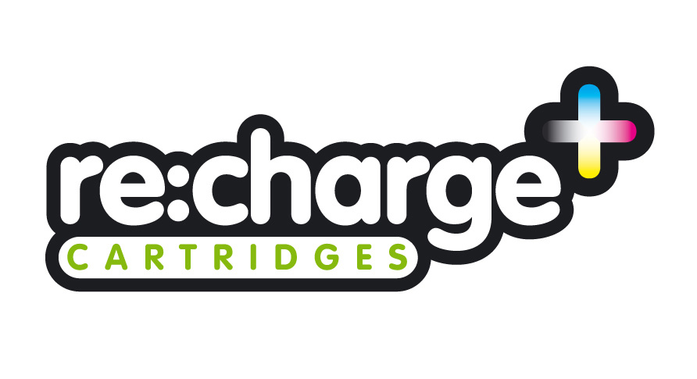

OUR NEW WEBSITE
SHOP ONLINE

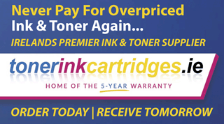

HP 300,301,302,901,303, 304,305,62, Ink Cartridge Errors
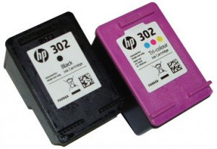NOTE: “Empty”, “Low Ink”, “Out of Ink“, “? Marks“, “Counterfeit” and “Non-Genuine Cartridge” alerts are COMPLETELY NORMAL for all HP 302, 302XL black and color ink cartridges which have been refilled!
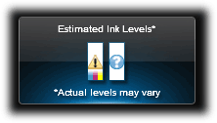
While at first this may be an unusual workflow, it does allow print operations to proceed.

3 Types of Alert Messages:
– Information Alerts. When a refilled ink cartridge is installed it is normal to receive alerts such as ‘non-genuine cartridge’ or ‘used color/black cartridge’. These may be bypassed by selecting ‘Dismiss’, ‘Ok’, or ‘Continue’.
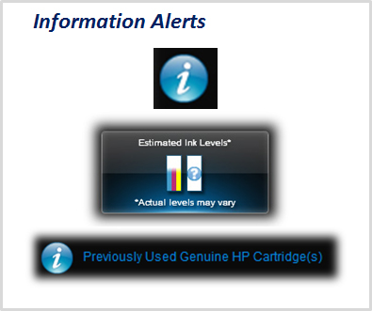
– Nuisance Messages. After a refilled ink cartridge is detected it is normal to receive alerts such as ‘low on ink’, ‘counterfeit’, ‘used’, ‘fraud’, ‘refilled’, or ‘depleted’ cartridge. These my be bypassed by selecting ‘Dismiss’, ‘Ok’, or ‘Continue’.
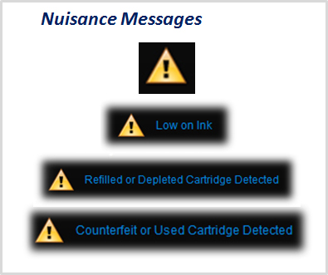
NOTE: If a “Non-HP Cartridge(s)” message, or similar message, cannot be bypassed then the cartridge may be suffering from marginal internal electrical performance and may need to be replaced with a new one. First remove and thoroughly clean cartridges electrical contacts & printer flex cable contacts and retest (refer to Printer Maintenance). If the problem persists then return cartridge for analysis.

Ink Cartridge & Service Station Cleaning
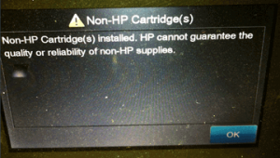

– Severe Errors. When an ink cartridge has poor connectivity (between contacts and flex cable inside printer) or is suffering from marginal internal micro-electrical performance, you may observe error messages such as ‘incompatible cartridges’, ‘print cartridges error’, ‘cartridge missing or not detected’, ‘refer to documentation’, ‘cartridge in left/right slot is missing’, etc. In addition, the power light may be blinking while the error message is displayed. In some cases, errors can be cleared by removing and cleaning the ink cartridges and printer flex cable contacts. If not, then it is suggested to run the cartridge health diagnostics (‘tap 41′) check or perform a cartridge error bypass (available on select printer models) to confirm that the ink cartridge is damaged.
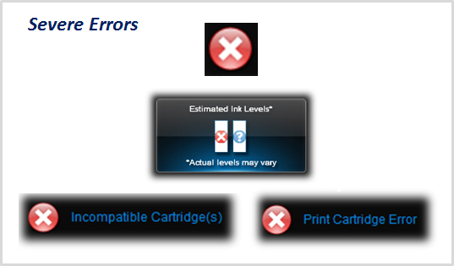
- Cartridge Electrical Failures. Severe cartridge errors are primarily caused by an electrical breakdown at the cartridge’s nozzle plate. Ink penetration or corrosion into the nozzle plate will cause a failure of the tiny micro-electronics resulting in a variety of different error messages being displayed.
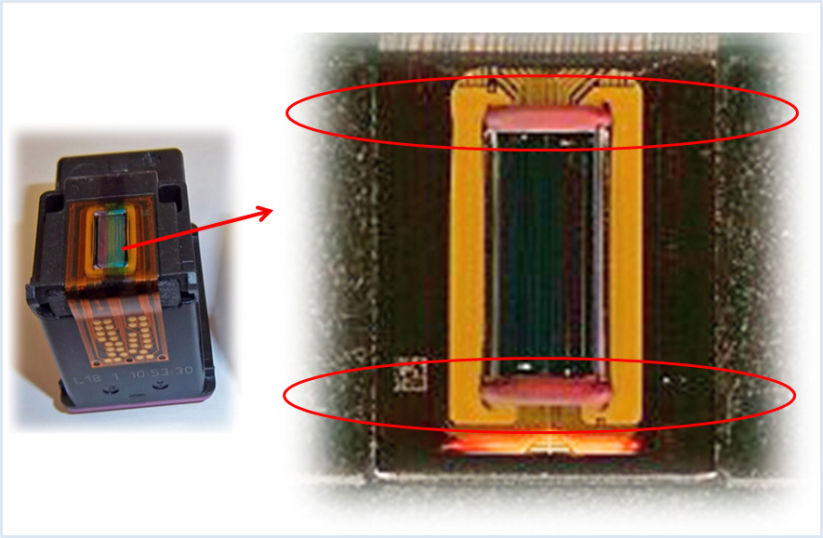
- Cartridge Diagnostics. The cartridge’s electrical health can be verified by running the ‘Tap 41′ diagnostics at the printer’s control panel (NOTE: not available on all printer models).

HP Nuisance Alert Messages
Following the installation of a refilled ink cartridge, nuisance or annoyance messages will typically be displayed after the initial ‘low ink’ or ‘non-genuine’ ink messages (NOTE: HP 302 & 302XL ink cartridges are similar to HP 301 and 301XL ink cartridges).

